CMIT 202 6385
PC Build and Manual Part I
September 9, 2018

Introduction: When building a computer there are many routes that can be taken depending on the users’ needs. Approximate date I need the computer? What is it going to be used for? How much will it cost? These questions will determine whether or not it is feasible for you to build your own PC or to purchase one from a store fully built.
This lesson will cover the ends and outs of building a PC for a more general and overall personal PC.
Tools required for installation of parts:
- (1) Anti-static Mat
- (1) Anti-static Wrist Strap with ground clip
- (1) Screwdriver, w/ multiple attachments
- (1) Thermal Paste pen
Parts required minimally for PC:
- (1) Intel i7-960, 3.2Ghz, 8 MB, CPU
- (1) Socket 1366, Motherboard
- (1) Socket 1366, Heatsink and Fan
- (1) ATX 20+4 PCI-E Power Supply
- (3) DDR3 2 GB 1600, RAM

Part 1 of 12: Preparation of Workspace
- Clean the work area of any clutter to avoid misplacement or accidents while building the PC
- It is incredibly important for the climate of your workstation be lower than 70% humidity and a temperature of 70-72 degrees Fahrenheit. Dry air is important to reduce the chances of ESD (Electrostatic Discharge)
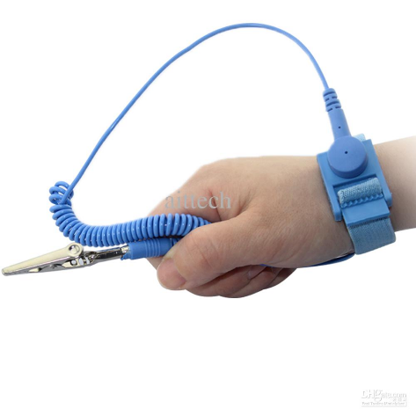
- Grounding yourself while handling computer parts will eliminate the risk of ESD. You can do this by using an Anti-static Wrist strap. When installing PC parts such as LCD panels, power supplies, other high voltage components do not use ESD wrist straps. Most probable environment for ESD is carpeted flooring. Prior to handling any components other than these ensure you have grounded yourself via ESD wrist strap around your dominant hand and clipped to the case frame.
Anti-static Wrist strap
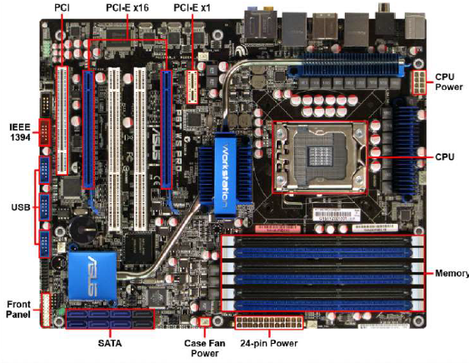
Part 2 of 12: Installation of the Motherboard

LGA 1366 Motherboard

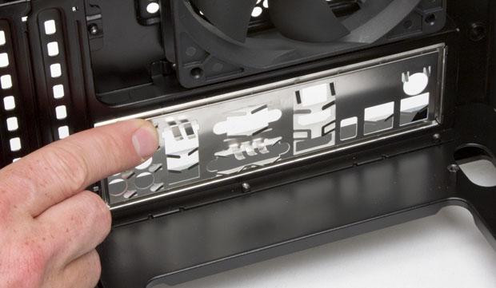
- Installation of the I/O shield: I/O shield is the input/output shield. Every motherboard comes with one and its purpose is to prevent debris from inserting into the case. To install the I/O shield you will need to place it on the back of the case as indicated in the graphic below. Once it is snapped into place you know it is secured.
I/O shield

- Installation of Standoffs: Connect the stand offs to the case making sure each of the holes are filled with stand offs. Standoffs supply as spacers preventing the motherboard from touching the casing.

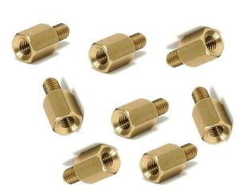
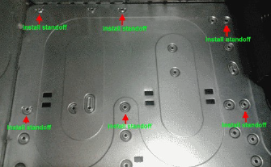
Motherboard Standoff

Standoff placement on case
D

- Anti-Static Mat: Before starting with any pc components ensure you are utilizing an Anti-static mat in your workstation. Next remove your LGA 1366 Motherboard from the anti-static bag and place it on the grounded mat.

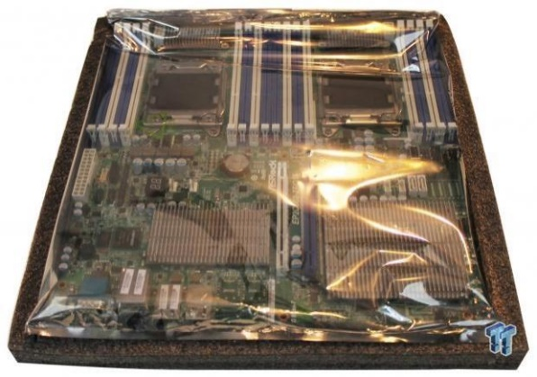
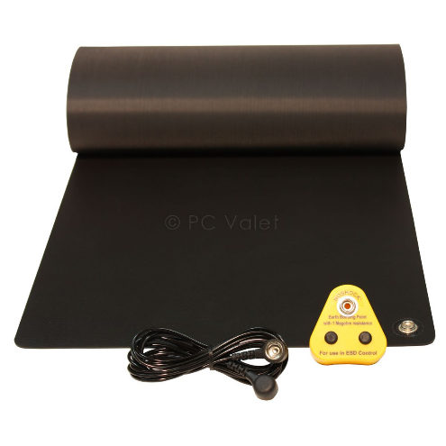

Anti-static bag for motherboards
Anti-static Mat

- Placement of the Motherboard: Take the motherboard from the Anti-static Mat and place in in the casing, ensure it is secured to the standoffs with insulated washers and screws. Note:

- System Panel Connectors: Once you have installed the motherboard to the case you will need to connect the cabling to the panel connectors. These cables are for the functionality of the speaker, LED’s, and panel switch. The motherboard will come with instructions that indicates where the pin layout is for these connectors.
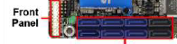
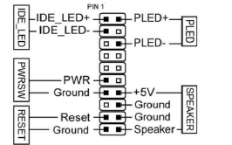
Top Left; Power LED. Top Right; Speaker. Bottom Left; LED. Bottom Middle; Case Power Switch. Bottom Right; Reset.

Part 3 of 12: Installing Power Supply: Note: during this portion of the installation the ESD wrist strap will NOT be utilized.
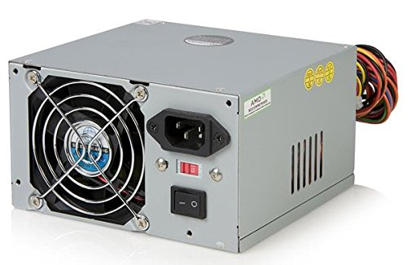
(a)
(a)

(b)
(c)
(a)

(1)
(a)

- Power Off to ensure there is no power running through the system.
  - Fasten Screws
  - Power Port
  - Voltage Switch on 115v

- Install the Power Supply to the casing with the cables facing inward and the power supply to the exterior. Utilize the screws in the positions where “(a)” is indicated on the graphic above to properly seat the power supply.

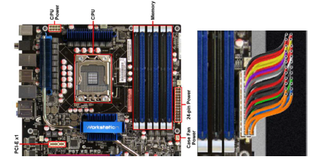
- After securing the power supply in the case, find your 24-pin female power port on the motherboard and insert the male 20+4 pin power cable. Ensure it is properly seated.
Motherboard

20+4 Pin properly installed in power supply.

Part 4 of 12: Installing CPU:
- Take your CPU out of the Static shield and place it on your static-mat
- Make sure the processor is in line with the motherboard socket and place the processor onto the socket ensuring the pins line up. Note: if it is angled it could potentially damage the processor.
- Secure the processor by latching the plate on the Land Grid Array or LGA. The LGA provides constant force over the entire processor to establish security.
- Next, we will be applying the thermal paste to the top of the processor as shown below. Only a small amount of paste is needed.
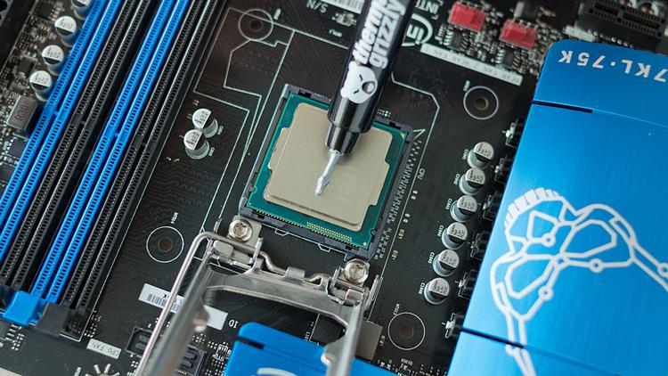
Notice only a small amount of Thermal Paste is being utilized

- Following the completion of adding the thermal paste we will quickly place the Heatsink and fan overtop of the thermal paste. Ensure you are aligned with the four screw holes in association with the motherboard.
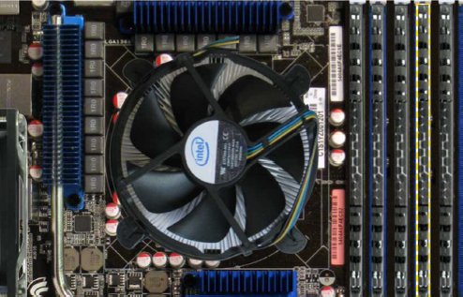

Properly installed heatsink / fan

- Once screwed in properly to the motherboard you will connect the 8-pin CPU and 4-pin fan power cables to the ports on the motherboard. As shown below.
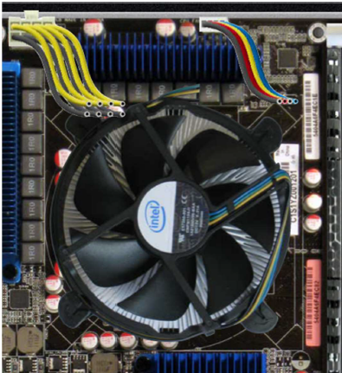
8-pin
4-pin

Properly installed heatsink / fan w/ connectors

Part 5 of 12: Installing RAM:
- Grab your Random Access Memory and place it on the anti-static mat.
- Next, locate the RAM slots on the motherboard as shown below.
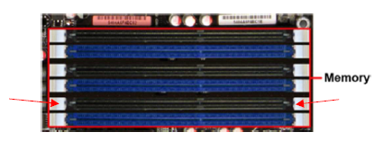
Latches
Latches
A1; Top. B1; Middle. C1; Bottom.

- After identifying the correct Ram slot align the Ram so the notches align with the latches. Firmly press down on the RAM. There will be feedback from the latches as they slide into place.

References:
- TestOut PC Pro. TestOut (Online). Derived from: Http://ww.testout.com

